Podcast Platform - RESTful APIs developed in JAVA and Frontend Web Site

consuming the APIs developed in AngularJS, Bootstrap, CSS3 and HTML5

INDEX:

1. CRUD for Customer
   1. Create New Customer
   2. Update existing Customer
   3. Delete existing Customer
   4. Get single Customer
   5. Get a invalid Customer
   6. Get all the Customers
2. CRUD for Podcast
   1. Create New PodCast
   2. Update existing PodCast
   3. Delete existing PodCast
   4. Get single PodCast
   5. Get all the PodCast
   6. Filter PodCast by Title
3. Version controller (V2) to Customer
   1. Create New Customer
   2. Update existing Customer
   3. Delete existing Customer
   4. Get single Customer
   5. Get all the Customers
4. Demo app (Angular JS)
5. RAML Documentation
6. Project Structure
7. Project Source Code
8. **CRUD for Customer**
   1. Create New Customer  
      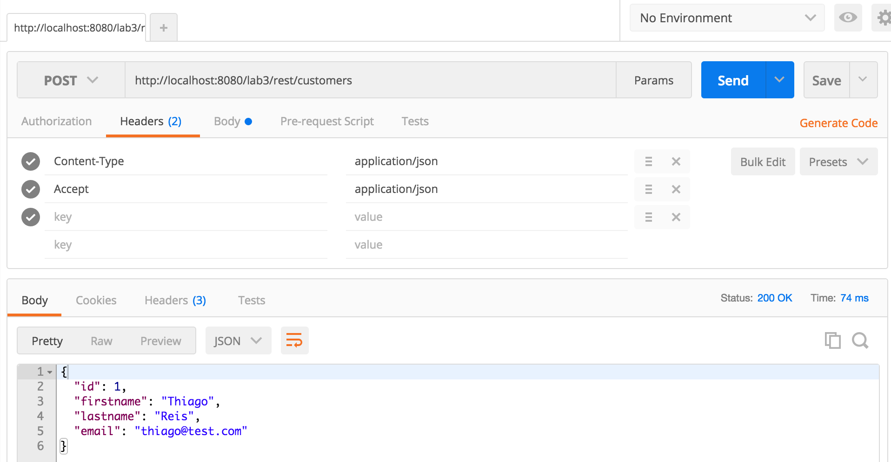|
   2. Update existing Customer

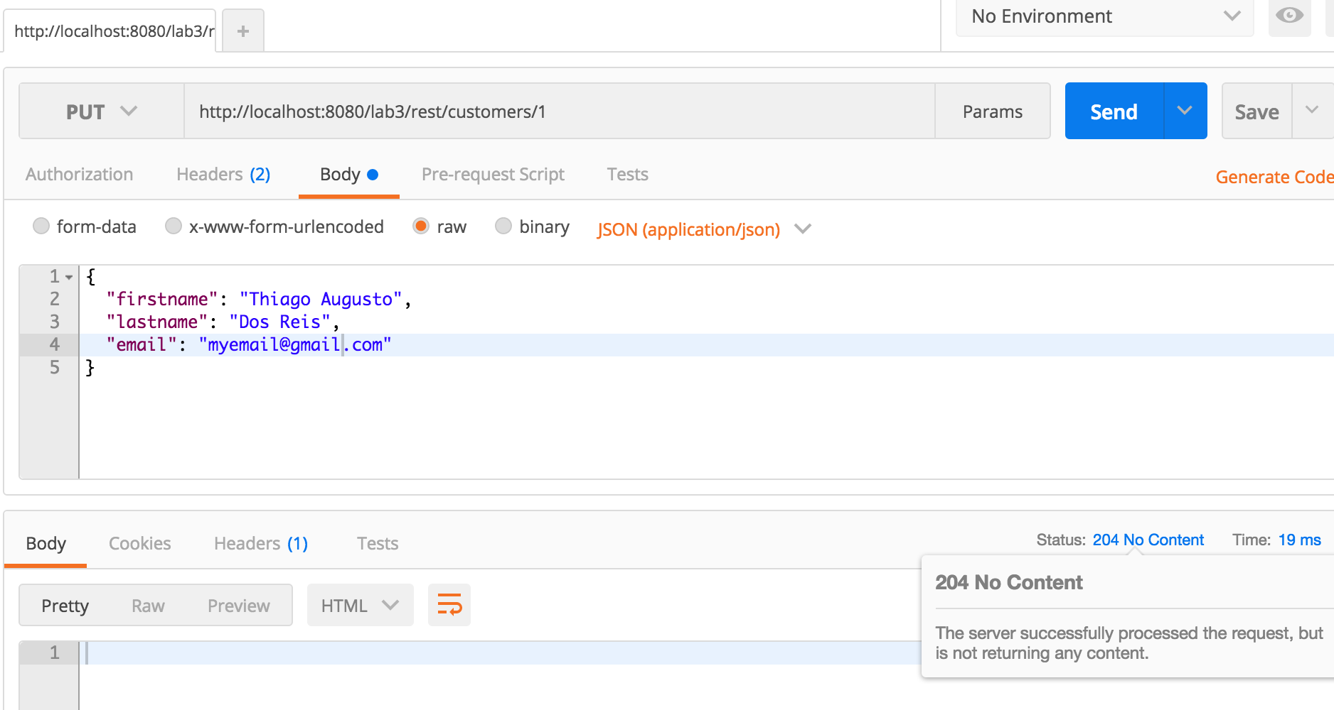

* 1. Delete existing Customer

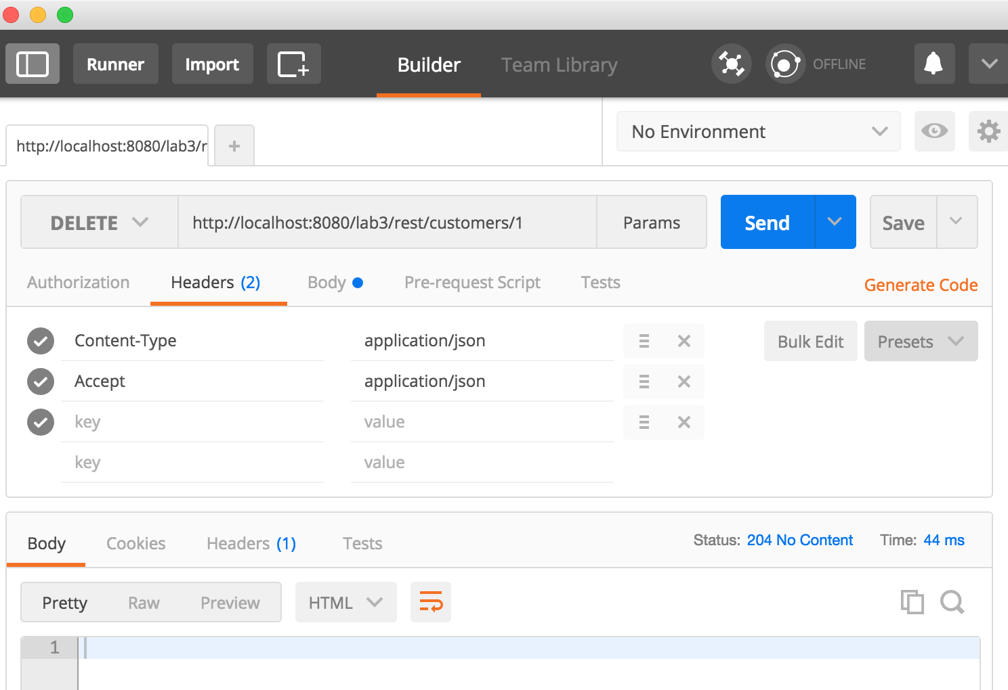

* 1. Get single Customer

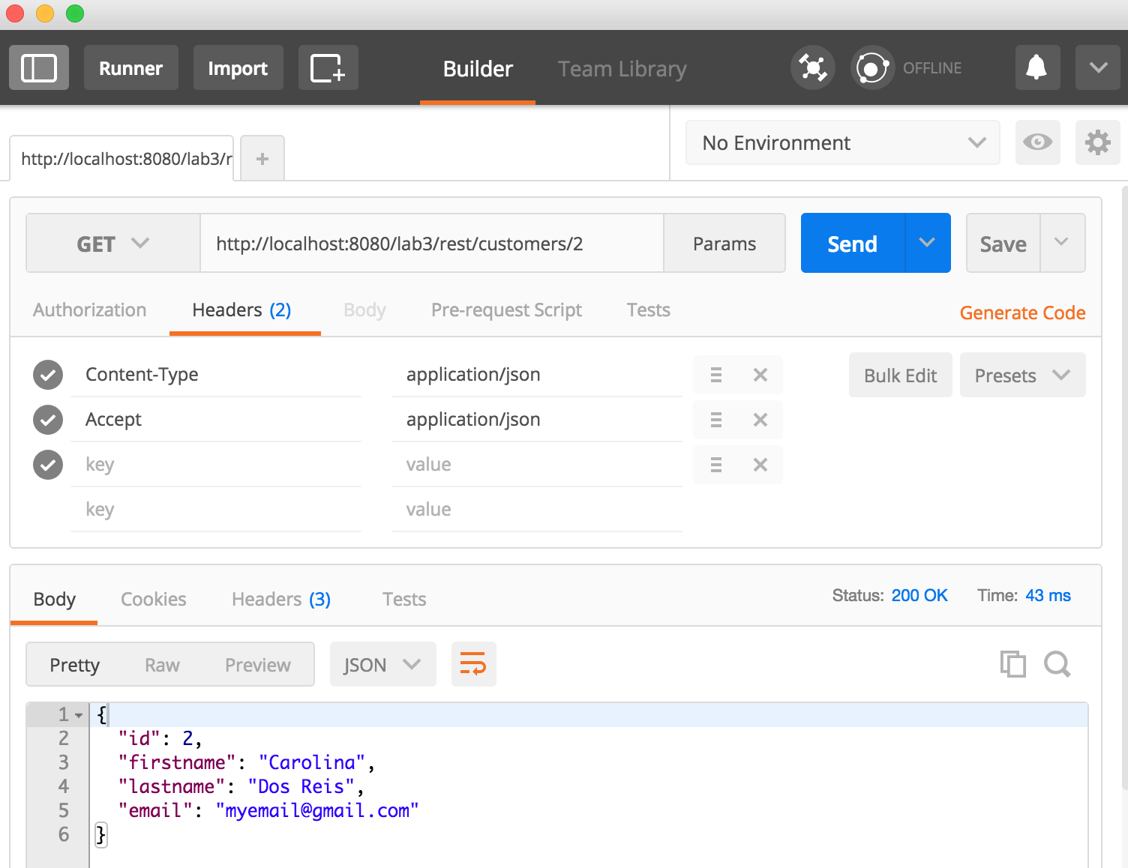

* 1. Get a invalid Customer  
     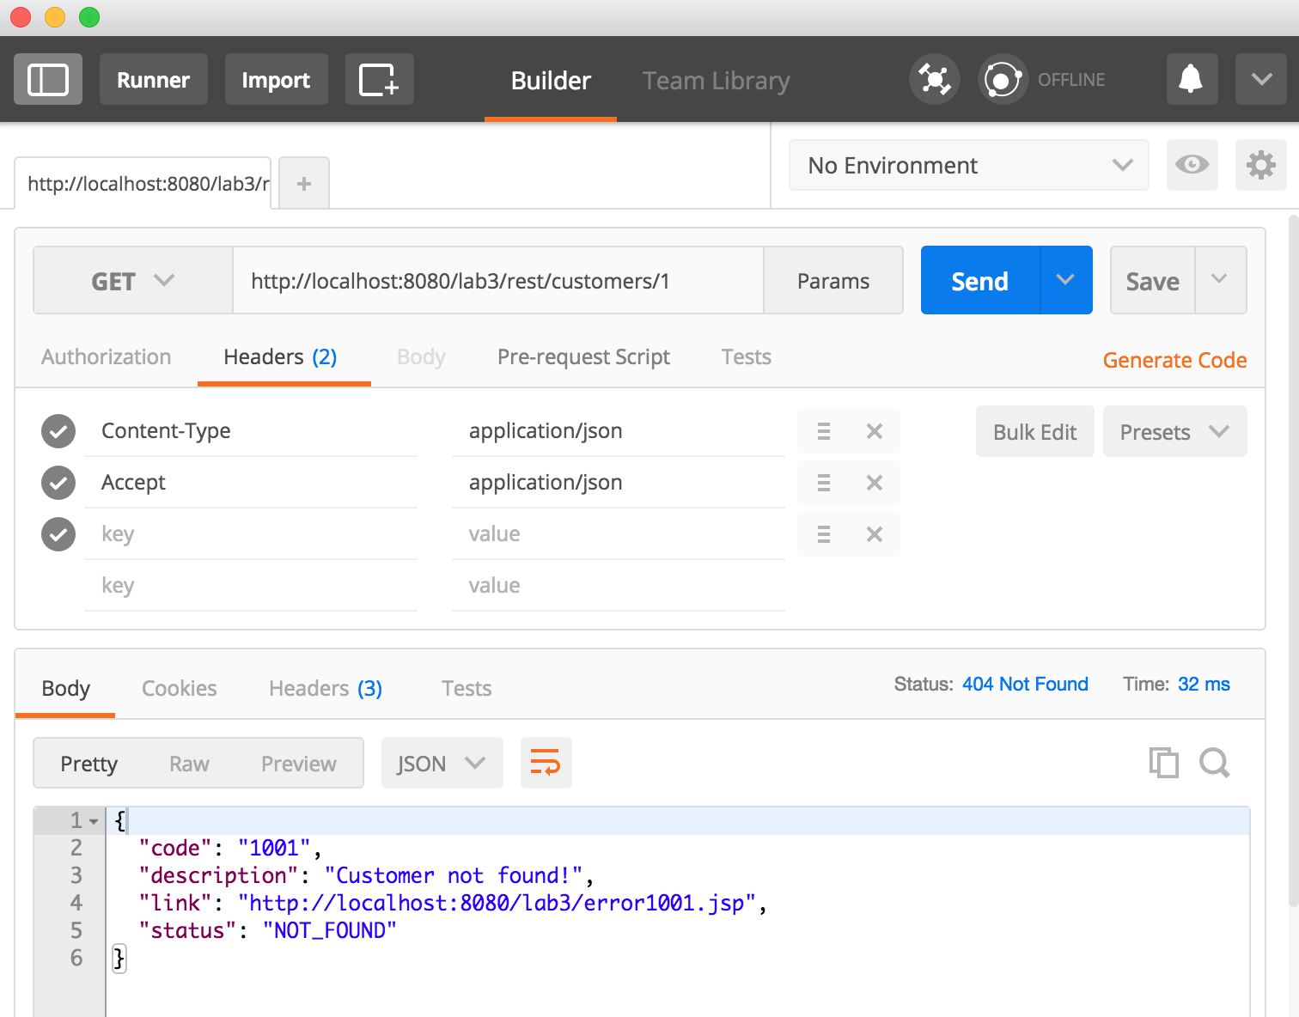
  2. Get all the Customers  
     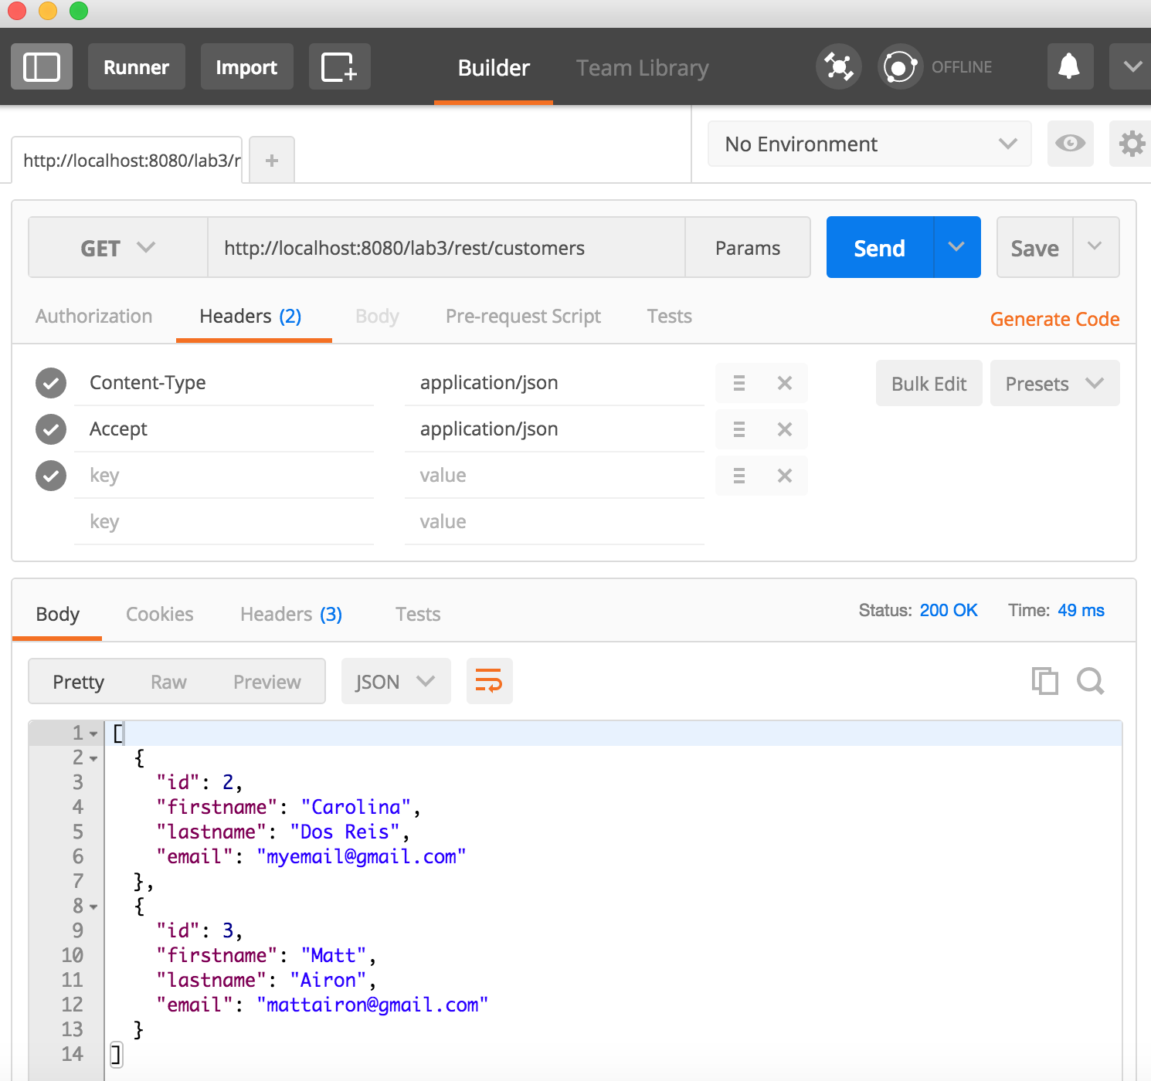

1. **CRUD for Podcast**
   1. Create New PodCast  
      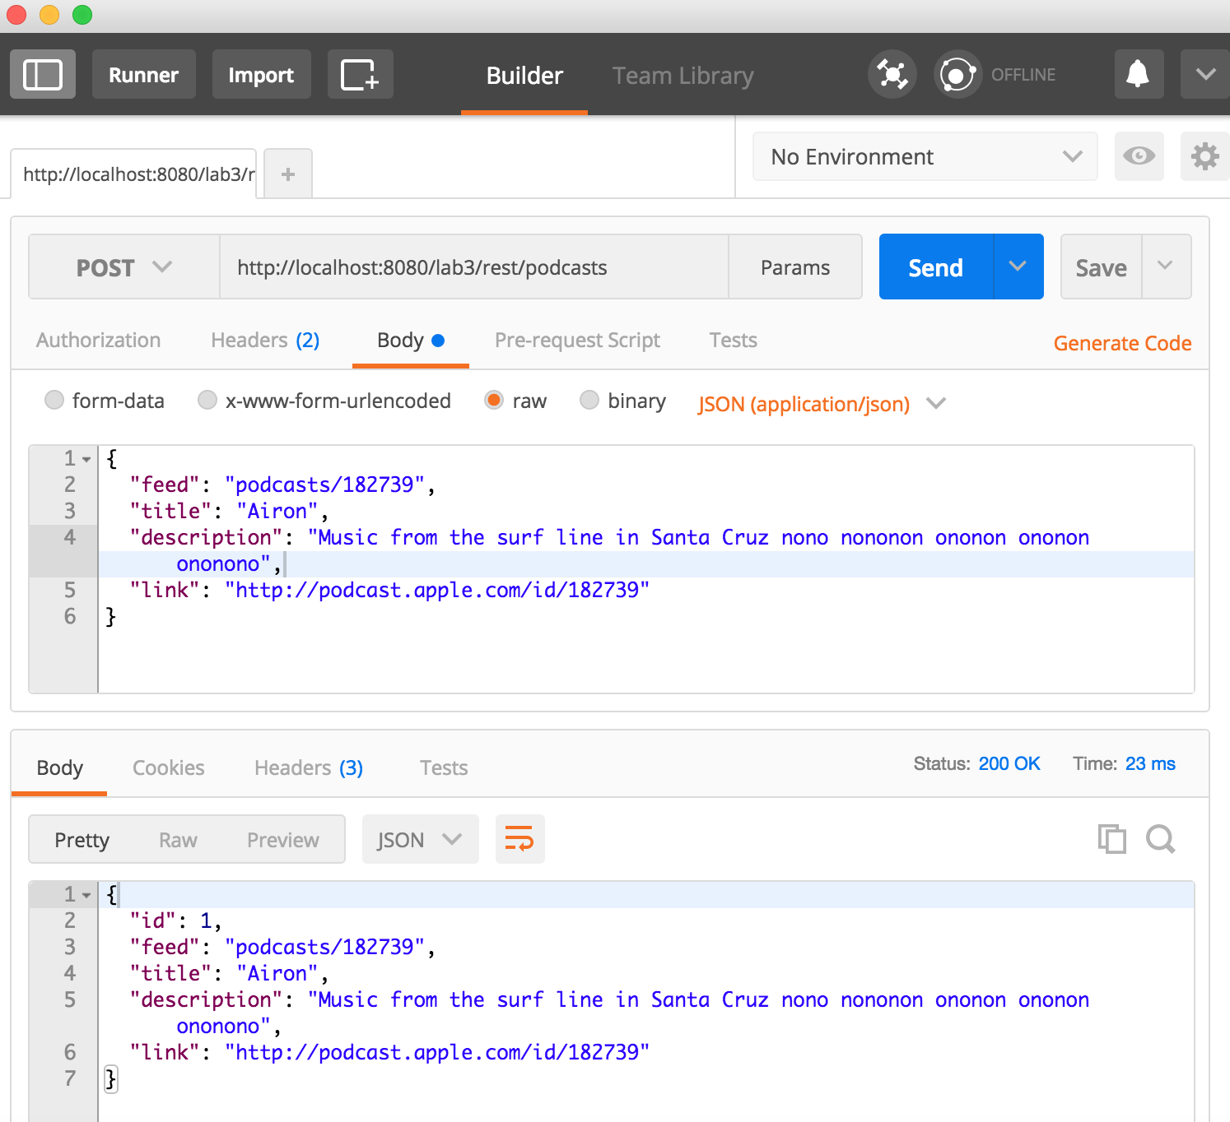
   2. Update existing PodCast  
      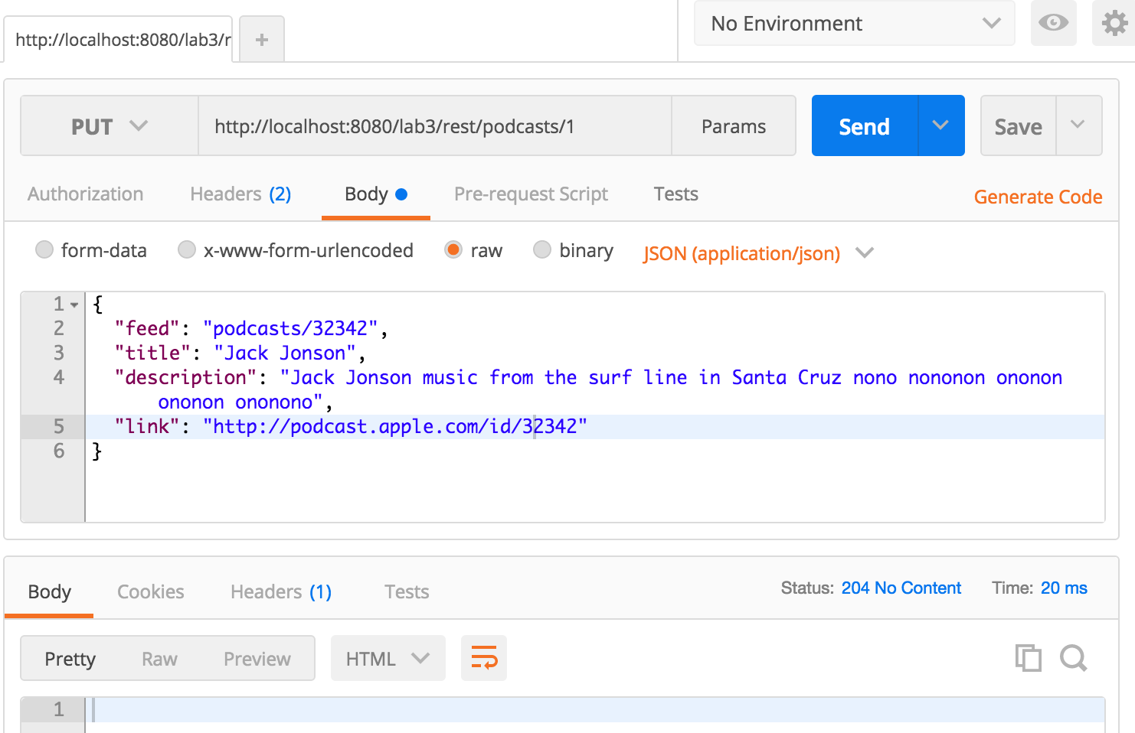
   3. Delete existing PodCast  
      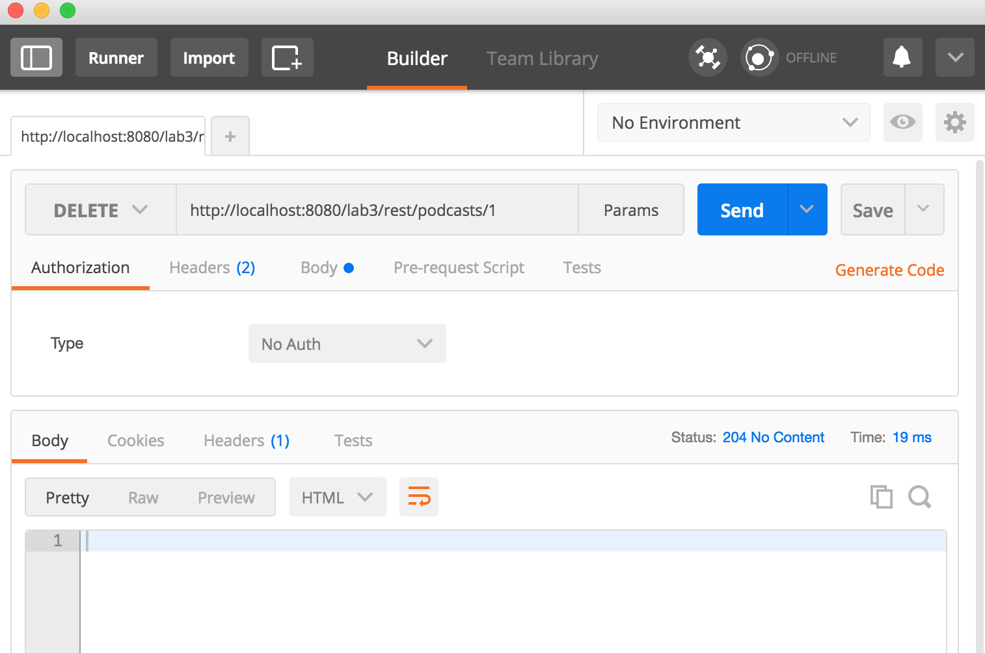
   4. Get single PodCast

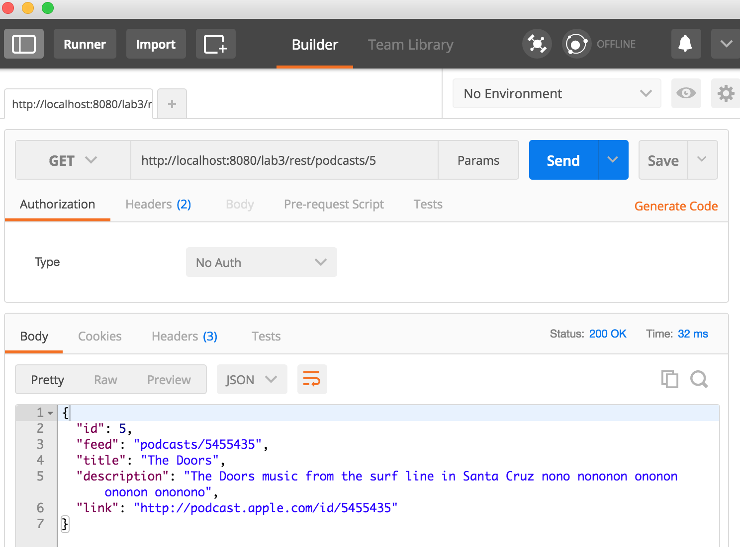

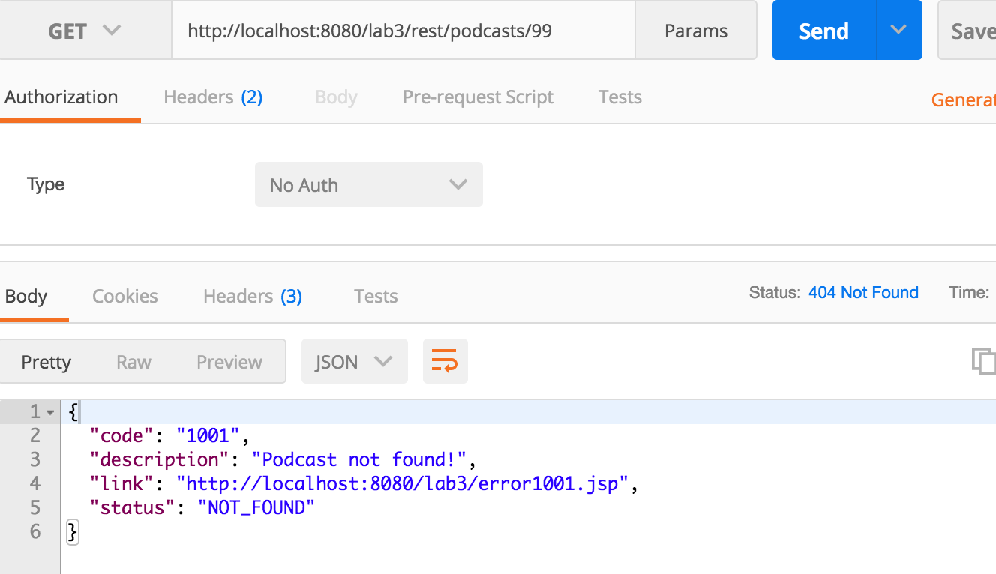

* 1. Get all the PodCasts  
     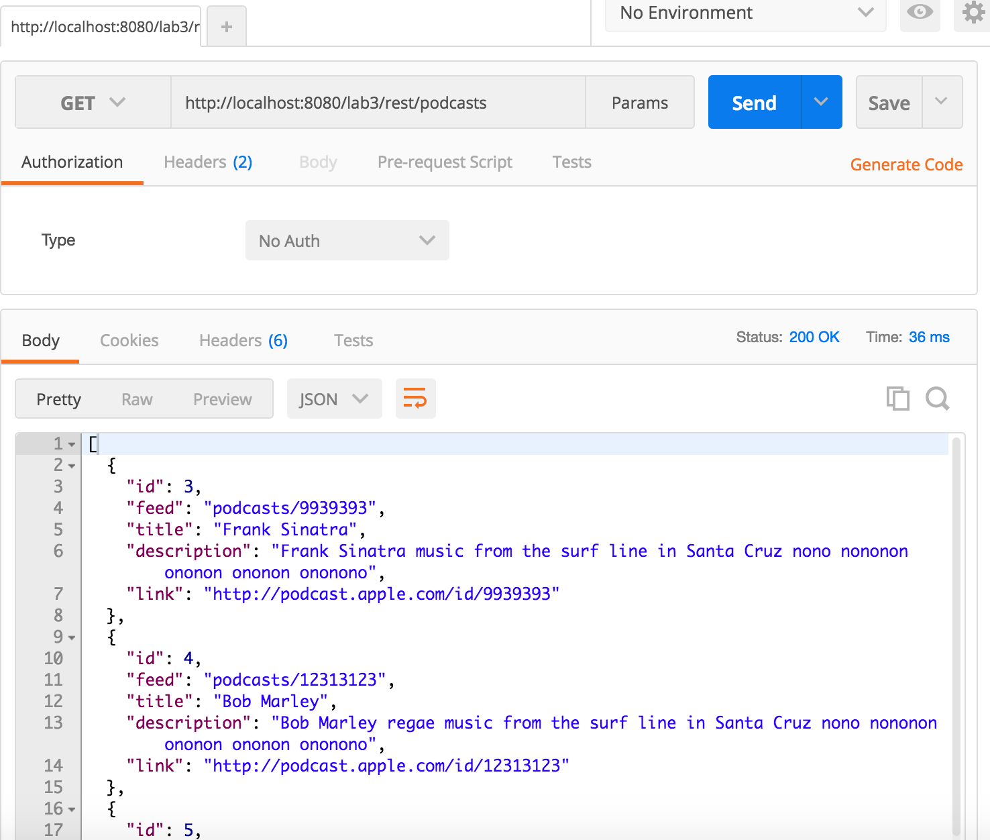
  2. Filter PodCast by Title

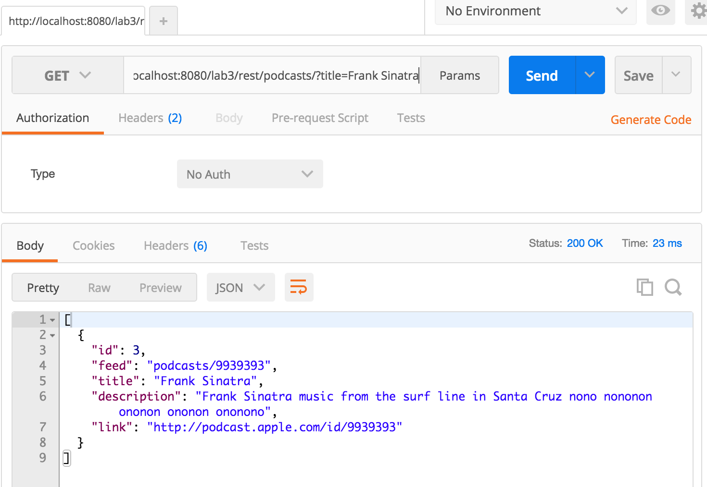

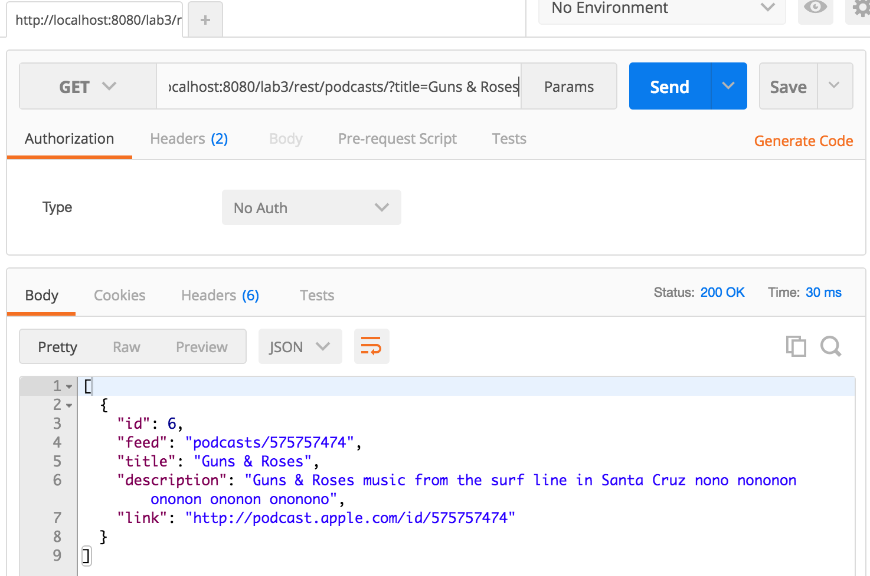

1. **Version controller (V2) to Customer**
   1. Create New Customer

Using Headers as v2+JSON to all transactions

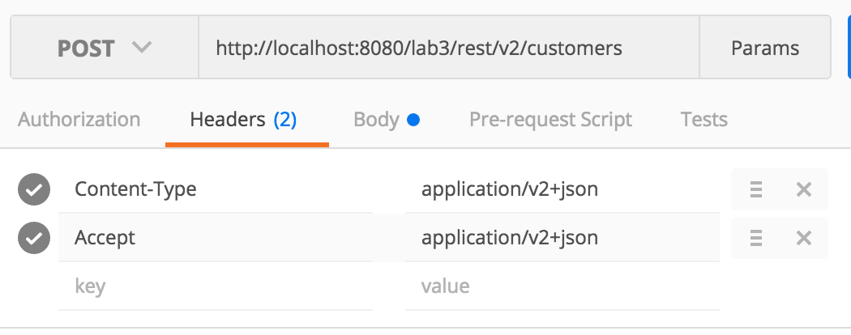

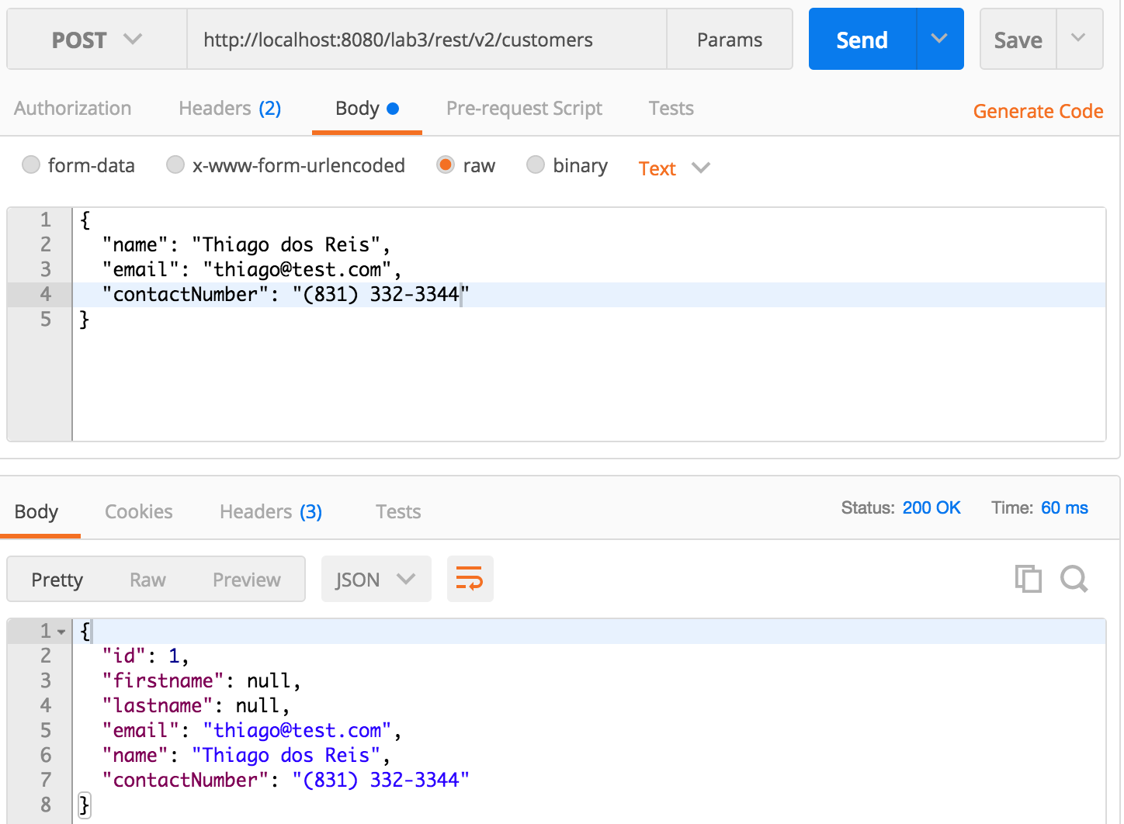

* 1. Update existing Customer  
     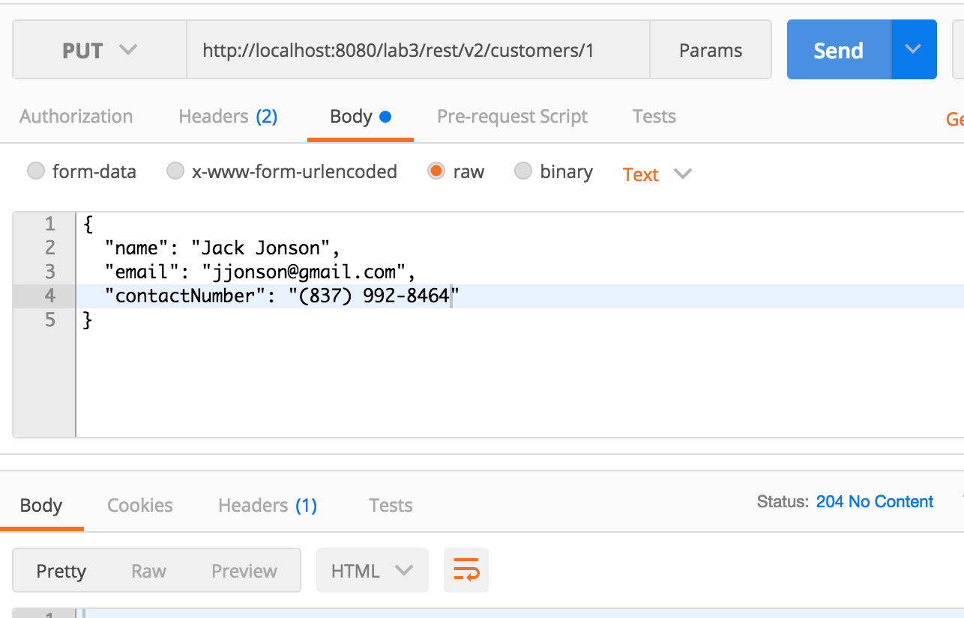

* 1. Delete existing Customer  
     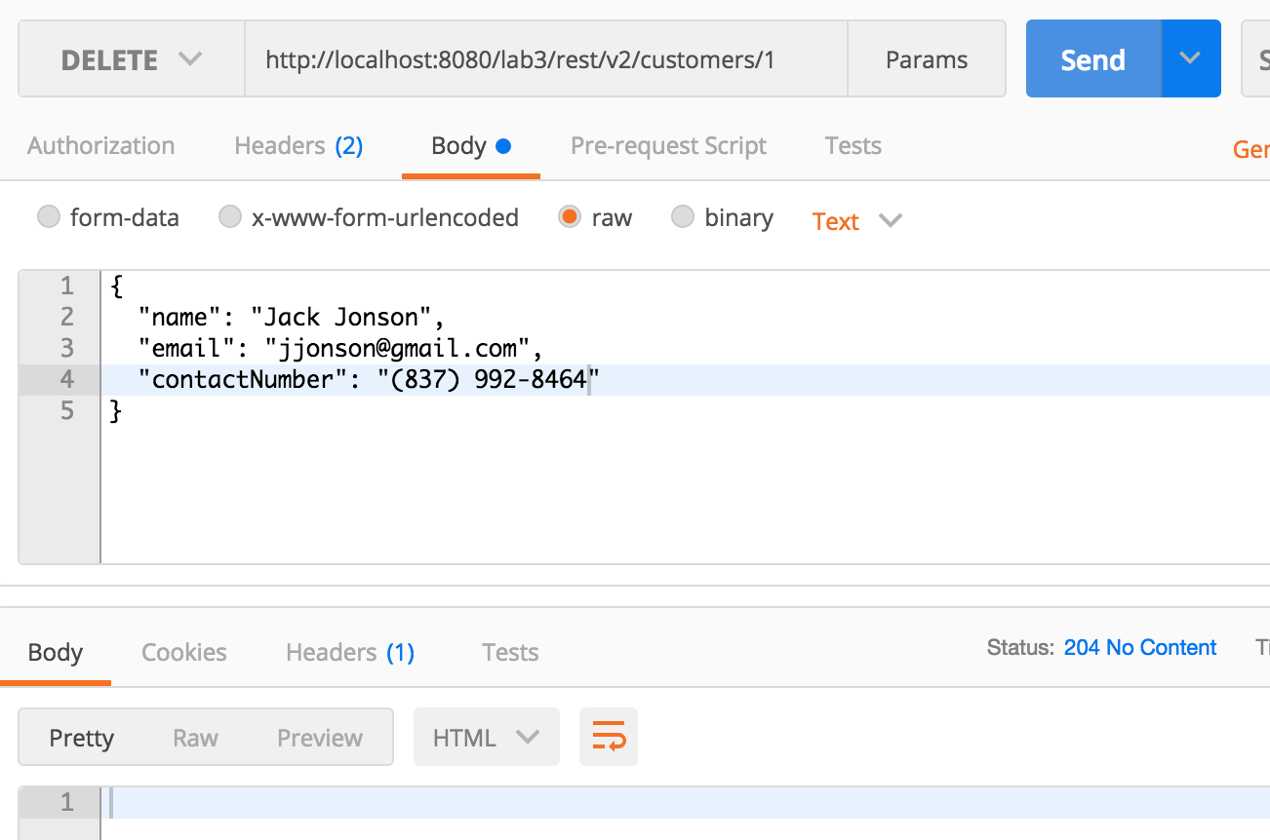
  2. Get single Customer  
     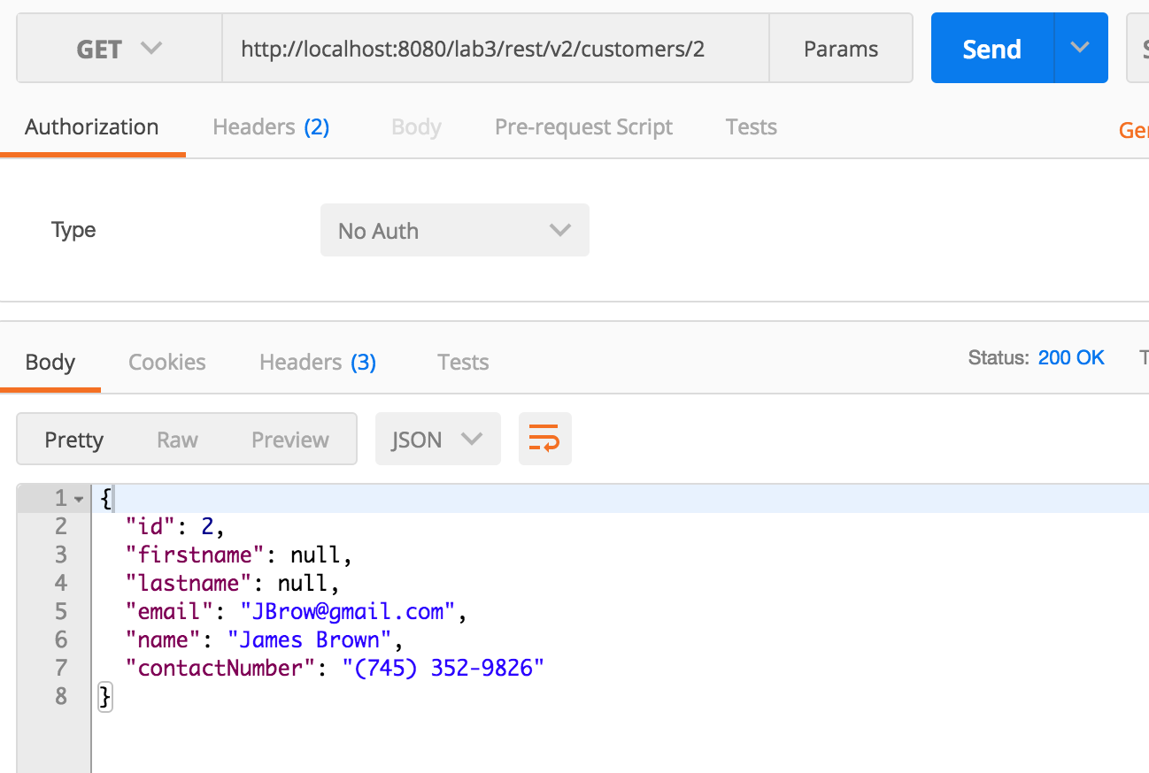

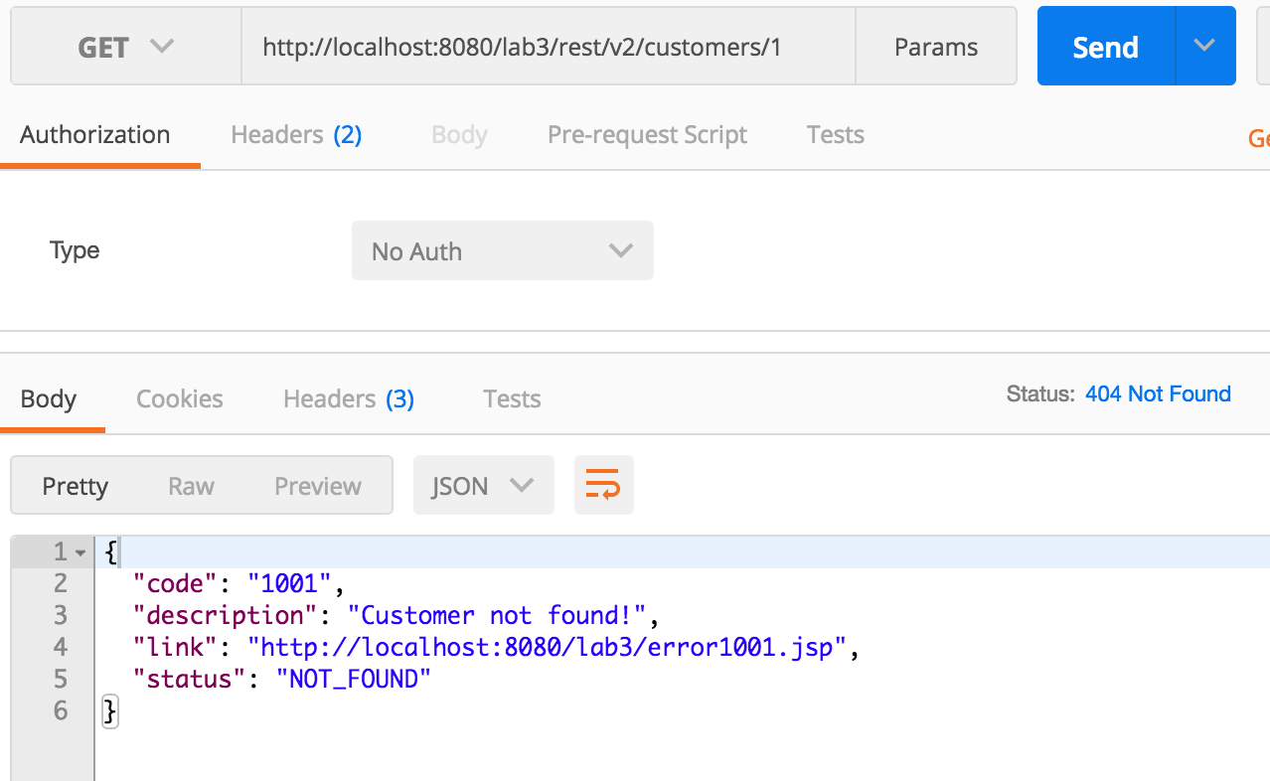

* 1. Get all the Customers  
     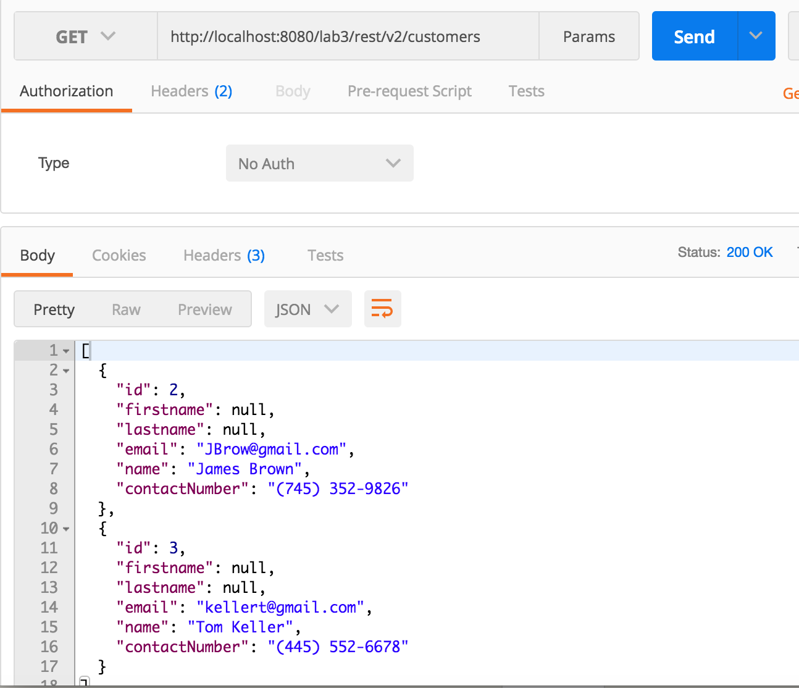

1. **Demo app** (using Angulas JS)

Getting all the PodCasts:  
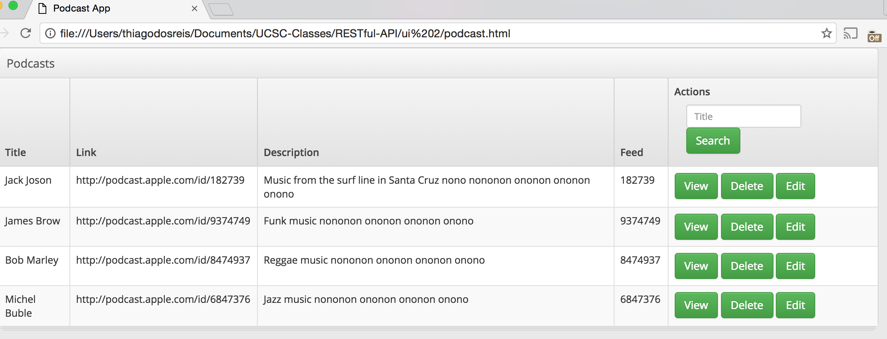

Filtering PodCasts by Title:  
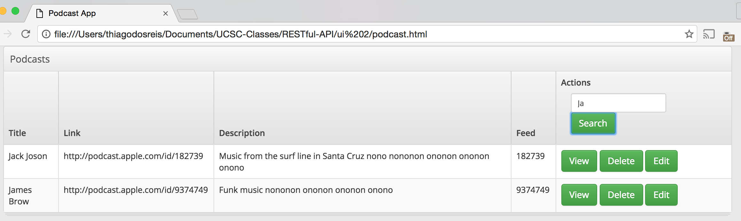

1. **RAML Documentation**I created just a very simple documentation to understand how it works and have a bit of hands on. Created on <https://anypoint.mulesoft.com>   
    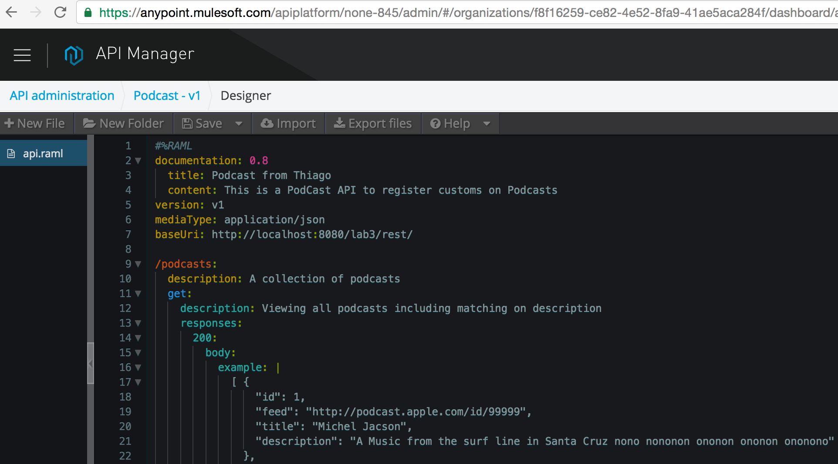

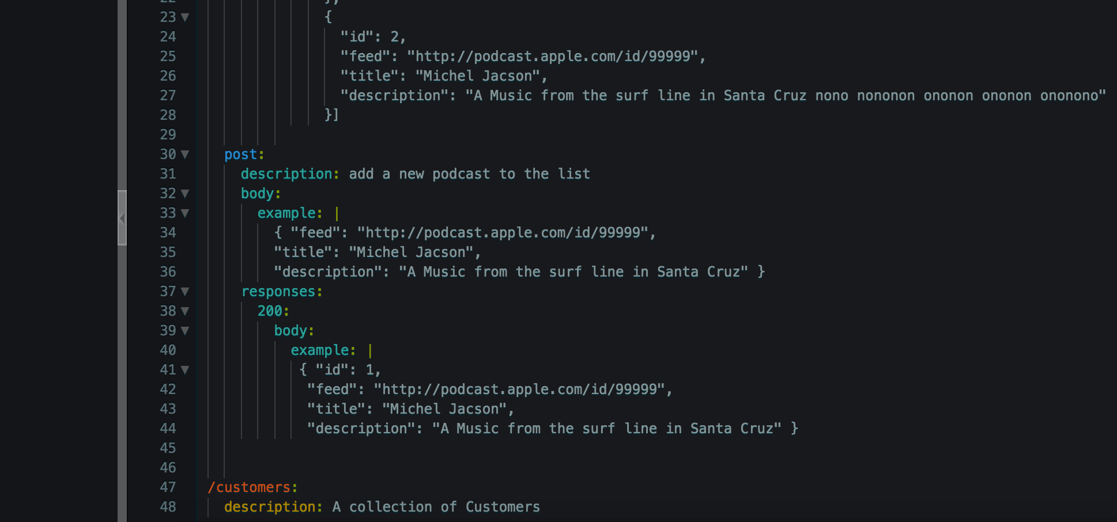

1. **Project Structure**

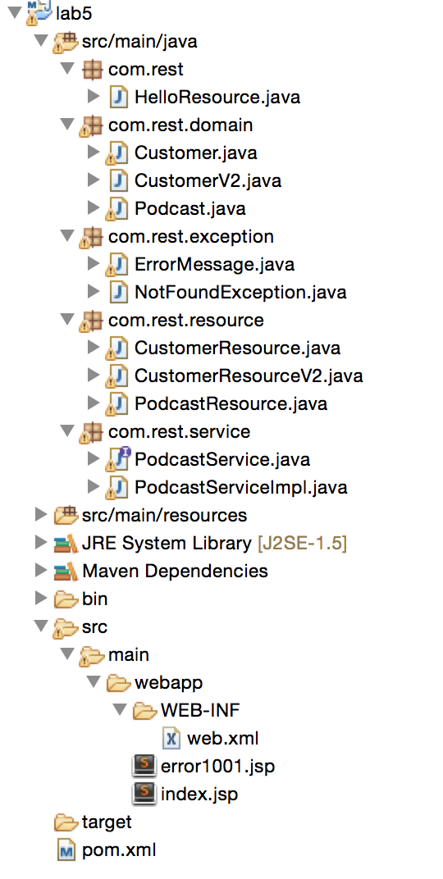

1. **Project Source Code**

All the project Files are in a separated .zip file attached to the UCSC Portal with this document.